TABLE 1

CREATE TABLE customer(customer_id int(10),cust_name char(30),city char(50),grade int (50),salesman_id int(50));

INSERT INTO customer(customer_id,cust_name,city,grade,salesman_id) VALUES (3002,'Nick Rimando','New York',100,5001);

INSERT INTO customer(customer_id,cust_name,city,grade,salesman_id) VALUES (3007,'Brad Davis','New York',200,5001);

INSERT INTO customer(customer_id,cust_name,city,grade,salesman_id) VALUES (3005,'Graham Zusi','California',200,5002);

INSERT INTO customer(customer_id,cust_name,city,grade,salesman_id) VALUES (3008,'Julian Green','London',300,5002);

INSERT INTO customer(customer_id,cust_name,city,grade,salesman_id) VALUES (3004,'Fabian Johnson','Paris',300,5006);

INSERT INTO customer(customer_id,cust_name,city,grade,salesman_id) VALUES (3009,'Geoff Cameron','Berlin',100,5003);

INSERT INTO customer(customer_id,cust_name,city,grade,salesman_id) VALUES (3003,'Jozy Altidor','Moscow',200,5007);

INSERT INTO customer(customer_id,cust_name,city,grade,salesman_id) VALUES (3001,'Brad Guzan','London','NOT null',5005);

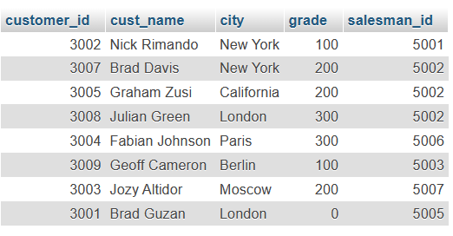

TABLE 2

CREATE TABLE salesman(salesman_id int (15) AUTO_INCREMENT NOT null PRIMARY KEY, name char (60),city char(50),commission float (5));

INSERT INTO salesman(salesman_id,name,city,commission) VALUES (5001,"James hoog","New York", 0.15);

INSERT INTO salesman(salesman_id,name,city,commission) VALUES (5002,"Nail Knite","Paris", 0.13);

INSERT INTO salesman(salesman_id,name,city,commission) VALUES (5005,"Pit Alex","London", 0.11);

INSERT INTO salesman(salesman_id,name,city,commission) VALUES (5006,"Mc Lyon","Paris", 0.14);

INSERT INTO salesman(salesman_id,name,city,commission) VALUES (5007,"Paul Adam","Rome", 0.13);

INSERT INTO salesman(salesman_id,name,city,commission) VALUES (5003,"Lauson Hen","San Jose", 0.12);

